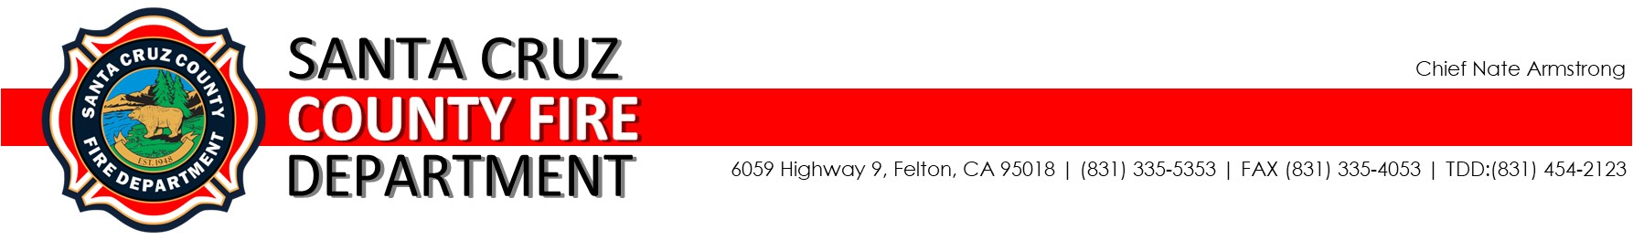LOAN SLIP

AUTHORIZATION
Date Loaned:
Scheduled Return Date:
Location:
 | Authorized Loaner | Signature
 | BC D. Bonfante
 | FC Manuel Garcia
 | FC James Kelly
 | OT Kim McGuire
 | FLO Bob Hunt
 | FLO Brittany Strohmayer

QUANTITY | UNIT MEAS. | ITEM DESCRIPTION
RECEIVER’S CONTACT INFORMATION

Name:
Phone:
Email:

The undersigned agrees that all loaned property of CZU Training and/or Santa Cruz County Fire Department as stated above will be returned by: ____________________________.

If all items are not returned as agreed, the receiver agrees to contact CZU Training by the above stated return date to make acceptable arrangements.

If, for any reason, the above stated items are not returned within 30 days of the scheduled return date, and no alternative agreement has been made, the receiver will be responsible for the full purchase price of the loaned items as determined by Santa Cruz County Fire Department.

Receiver’s Signature: ______________________________Date: ____________________

